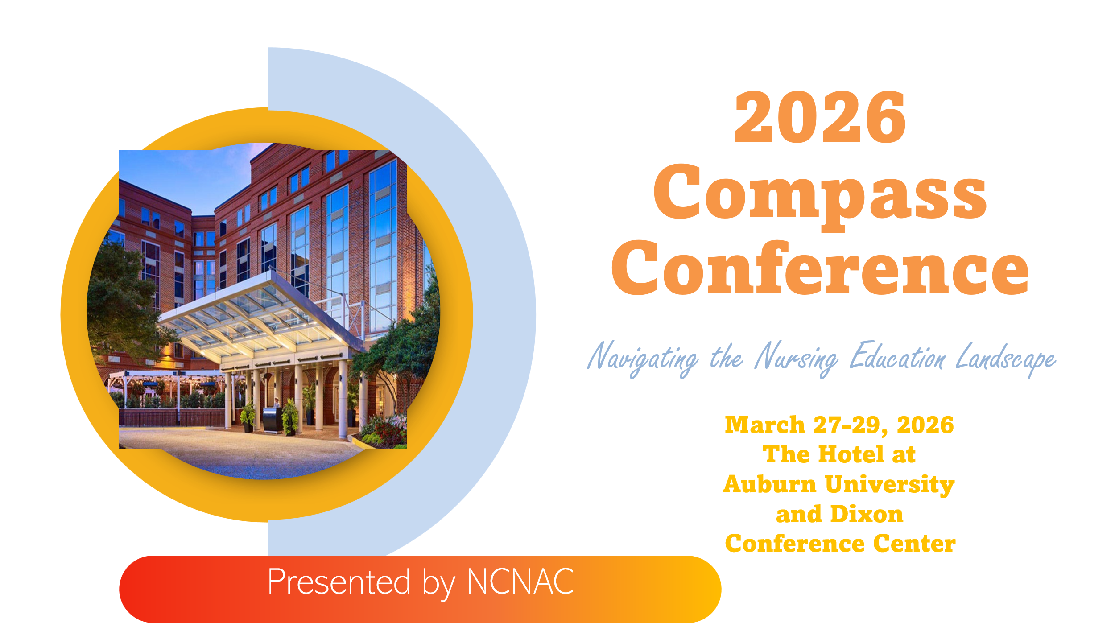

We are now accepting submissions for Podium and Poster presentations.
https://auburn.qualtrics.com/jfe/form/SV_4TlXebCgDqN6YSy
Podium Presentations are 40 minutes with 5 minutes for questions
Poster Presentations will be displayed at the conference during the welcome reception and throughout the weekend.
